Malware Types & Behavior Analysis Report
Title:
Malware Types and Behavior Analysis Using VirusTotal
Submitted By:
Name: Adil Firoz
Internship Program: Cyber Security Internship
Task: Task 5 – Malware Types & Behavior Analysis
Tool Used: VirusTotal
Date: 22-012026
1. Introduction
The objective of this task is to understand different types of malware and analyze their behavior using online malware analysis tools. In this task, malware classification, detection reports, behavior indicators, and prevention techniques were studied using VirusTotal.
This analysis provides basic awareness of malware threats and detection methods.
2. Types of Malware
Malware is malicious software designed to harm computer systems or steal information.
Common malware types include:
Virus – Attaches itself to legitimate files and spreads when executed.
Worm – Self-replicates and spreads automatically through networks.
Trojan – Disguised as legitimate software but performs malicious actions.
Ransomware – Encrypts user files and demands ransom for decryption.
3. Malware Sample Analysis Using VirusTotal
A known malware hash was analyzed using VirusTotal. The hash was searched directly instead of uploading a file to ensure safe analysis.
VirusTotal provided detection results from multiple antivirus engines along with threat classification and detection ratio.
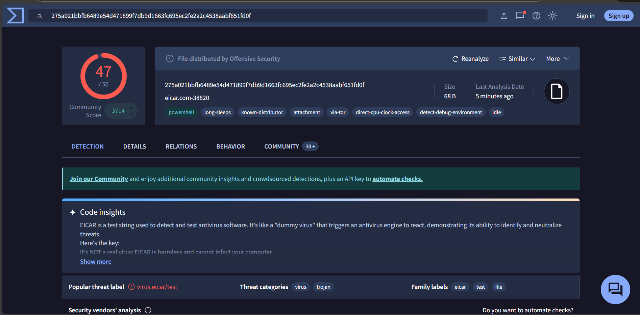
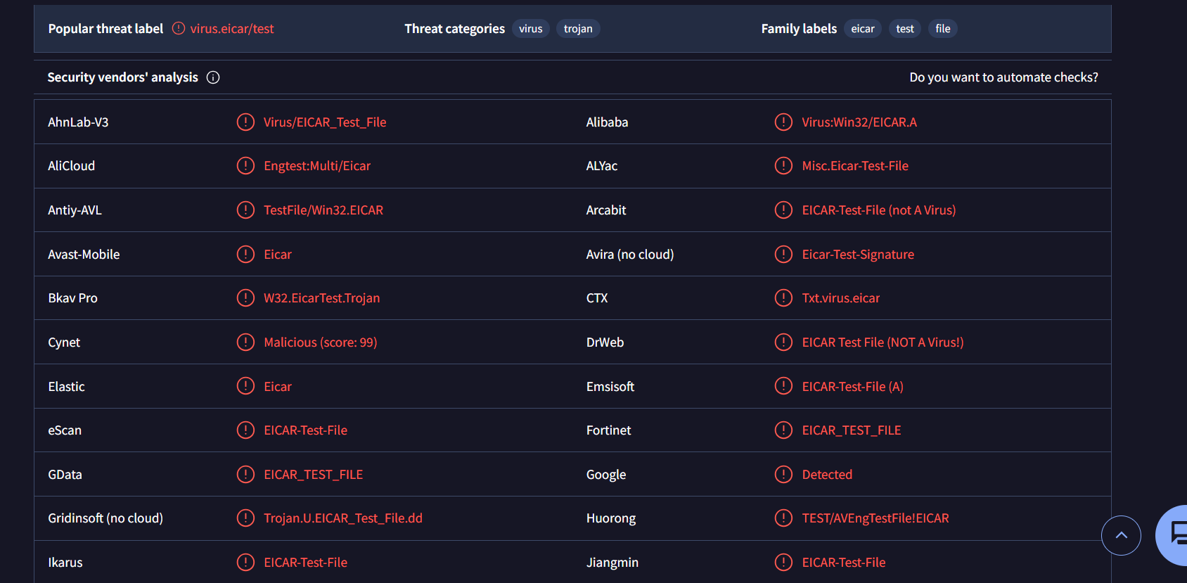
Figure 1: VirusTotal detection report showing malware classification
4. Detection Report Analysis
The detection report showed that multiple antivirus engines detected the file as malicious. The malware was classified as a Trojan and identified with several threat names by different security vendors.
This confirms that the analyzed sample is a known malicious file.

5. Behavior Indicators
Behavior indicators observed in VirusTotal included suspicious file activity, network connections, and system modifications.
These indicators show how malware attempts to execute, persist in the system, and communicate with external servers.
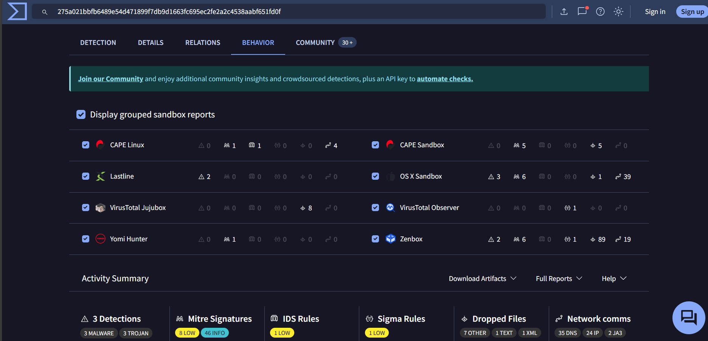
Figure 2: Behavior indicators observed in the malware analysis report
6. Malware Lifecycle
The malware lifecycle consists of the following stages:
1. Delivery – Malware enters the system through email, links, or downloads
2. Execution – Malware runs on the system
3. Persistence – Malware maintains access after reboot
4. Propagation – Malware spreads to other systems
5. Command and Control – Malware communicates with attacker servers
6. Payload – Malicious action such as data theft or encryption
7. Malware Spread Methods
Malware commonly spreads through:
- Malicious email attachments
- Phishing links
- Infected USB drives
- Pirated software downloads
- Exploiting system vulnerabilities

8. Prevention Methods
The following prevention methods can reduce malware infections:
- Install and update antivirus software
- Keep operating systems and applications updated
- Avoid opening unknown email attachments
- Do not click suspicious links
- Enable firewalls and security monitoring
9. Observations
The following observations were made during the analysis:
- Malware can be detected by multiple antivirus engines
- Detection ratios indicate threat severity
- Behavior analysis helps understand malware activity
- Early detection reduces system damage

10. Conclusion
The following observations were made during the analysis:
- Malware can be detected by multiple antivirus engines
- Detection ratios indicate threat severity
- Behavior analysis helps understand malware activity
- Early detection reduces system damage

